January 23: Jane Hoogestraat

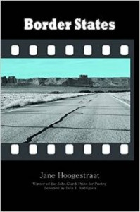

7 p.m., Plaster Student Union Theater
Born in South Dakota, Jane Hoogestraat was educated at Baylor and at the University of Chicago. Her work has appeared in such journals as Poetry, The Southern Review, DoubleTake, Image, Midwestern Gothic, and Crab Orchard Review. She is a professor of English at Missouri State University, where she specializes in 20th century poetry and literary theory, with a particular interest in ethics and aesthetics. Her latest book, Border States, won the 2014 John Ciardi Prize for Poetry.

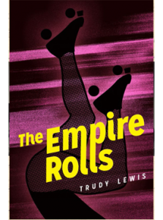

March 6: Trudy Lewis

7 p.m., Plaster Student Union Theater
Trudy Lewis is the author of the novels The Empire Rolls (Moon City Press), the initial book in our Missouri Authors Series, along with the novel Private Correspondences (Tri/Quarterly/Northwestern University Press), and the short story collection The Bones of Garbo (The Ohio State University Press). Her short stories have appeared in Atlantic Monthly, Best American Short Stories, Cimarron Review, Cold Mountain Review, Meridian, New England Review, New Stories from the South, Prairie Schooner, Shenandoah, Witness, and other venues. Trudy is the recipient of the William Goyen Prize, the Sandstone Prize for Short Fiction, and the Glenna Luschei Prize from Prairie Schooner. She is currently Director of Creative Writing at the University of Missouri.

March 17: Ed Madden 7 p.m., Plaster Student Union Theater 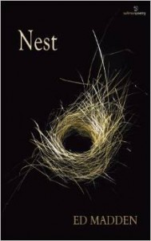
Ed Madden is an associate professor of English and interim director of the Women’s and Gender Studies program at the University of South Carolina. He is the author of two books of poetry: Signals, which won the 2007 South Carolina Poetry Book Prize, and Prodigal: Variations (2011), and most recently, Nest (2014). In addition to his creative output, Madden has published numerous scholarly works, including Tiresian Poetics: Modernism, Sexuality, and Voice 1888-2001. He co-edited Irish Studies: Geographies and Genders with Marti Lee. His academic areas of specialization include late 19th- and 20th-century British and Irish poetry, Irish culture and literature, gender and sexuality, gay and lesbian literature, and creative writing. Madden received his B.A. from Harding University and earned his Ph.D. in literature from the University of Texas.

Posted in Announcement, Current Events, Readings, Uncategorized | Comments Off

