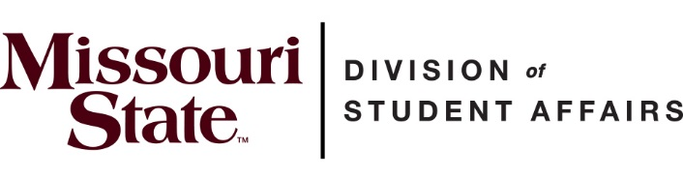
Student Affairs Student Advisory Board
2020-2021 Application
Board Description
The Division of Student Affairs Student Advisory Board exists to provide an open dialogue and discussion between Missouri State University students and the Vice President for Student Affairs. This twelve-member board will be charged with:
- providing input to the Vice President regarding out-of-classroom experiences
- offer a glimpse into the lives of Missouri State students
- providing a voice on current issues affecting students
The board will meet during the lunch hour throughout the Via Zoom for the fall semester. The meetings are coordinated by the Office of Student Affairs and hosted by the Vice President for Student Affairs.
Meetings
Students are encouraged to attend all meetings and are expected to meet one-on-one with the Vice President for Student Affairs, Dr. Dee Siscoe, during the fall semester.
Benefits
Student Advisory Board members will
- Have their picture and bio posted on the Student Affairs website during their tenure on the board
- Have the opportunity to network with university administrators
Requirements
Students must
- Have a 2.5 GPA or higher to serve on the Student Advisory Board. Participation is open to both undergraduate and graduate students.
- Be enrolled as a full-time student on the MSU Springfield campus and should regularly check their MSU live email account
Student input is very valuable to Dr. Siscoe so it is important to have students who are committed to the board, although we realize conflicts may arise due to class schedules. If you find you cannot attend the meetings, as a board member you must notify the Office of Student Affairs through email one month prior to discontinuing your membership

Student Affairs Student Advisory Board
2020-2021 Application
Name: ________________________ Phone #:________________________
Major: ________________________ E-mail Address: __________________
Minor(s): ______________________ Year in School: __________________
Hometown: ____________________ GPA: __________________________
Hours Completed: _______________ M#:____________________________
Mailing Address: ______________________________________________________________
Dietary Restrictions: ___________________________________________________________
I hereby release my number of credit hours and GPA information to the Office of Student Affairs.
Signature: _____________________________ Date: ____________________
Please answer the following prompts on a separate sheet of paper using no more than 200 words per question:
- List campus, community, and other relevant involvement including leadership positions held in college.

- What do you consider to be a major issue facing college students today (either on Missouri State’s campus or nationally)?

- In what ways can you advocate for student needs within the Student Advisory Board and the Division of Student Affairs?

- What are you hoping to gain from serving as a member of the Student Advisory Board?

Please submit printed applications or email to Peggy Jones in the Office of Student Affairs (Carrington 200) by 5pm on Monday, August 31, 2020.
If you have any questions or concerns, please contact Peggy Jones, Executive Assistant for the Office of Student Affairs, at peggyjones@missouristate.edu

