College of Natural and Applied Sciences May 13, 2022

Missouri State University

In 2022 CNAS recognized outstanding faculty and staff for the eleventh straight year. The award winners were nominated by departmental personnel committees, department heads, or students. The nominations were then reviewed by a faculty committee for the faculty/staff awards and by a student committee for the student-nominated awards. I am proud to announce the following award winners for 2022! The award winners receive a certificate and a small monetary award.

CNAS Excellence Award – Staff

Scott Curtis – Laboratory and Stores Supervisor, Department of Chemistry and Biochemistry

Scott Curtis, started working in the Chemistry and Biochemistry Department in April 2021. In less than one year, the department feels much different with Scott in charge of the stockroom. He completely updated the chemical stockroom inventory system and restarted the barcode scanner system, which gives an easy way to locate an item anywhere in the stockroom. Scott conducted a large-scale cleanout of the stockroom that saw the elimination of large amounts of unused, expired, and needlessly hazardous chemicals, freeing up a considerable amount of space.

CNAS Faculty Excellence in Service Awards

Cameron Wickham - Mathematics

Melida Gutierrez – Geography, Geology and Planning

Keiichi Yoshimatsu – Chemistry and Biochemistry

Tina Hopper – Biology

Melissa Schoeben - Biology

Cameron Wickham, professor of mathematics serves as an active member of the Algebra curricular committee and always participates in Pummill Math Relays. He has served on the Faculty Senate for a several years, first as a Faculty Senator, and then as the Chair for the academic year 2020 to 2021. He serves as referee for professional journals including Communications in Algebra, Journal of Pure and Applied Algebra, Journal of Commutative Algebra, and International Electronic Journal of Algebra.

Melida Gutierrez, professor of geology, reviewed twenty-two manuscripts from various academic journals and served as the guest editor of a special issue of the journal Minerals: Sustainable Use of Abandoned Mines. (Impact Factor of 2.3) in the past two years. She is a member of GGP’s Faculty Evaluation Committee, chair of college RPT Committee, and she serves as a mentor for the Louis Stokes Alliance Minority Program.

Keiichi Yoshimatsu, associate professor of biochemistry, led efforts to improve the learning experiences of students to include curriculum changes to both general chemistry and more advanced courses as chair of the Undergraduate Curriculum and Recruitment Committee and Summer Undergraduate Research Promotion Committee. He is a faculty advisor to both Student Affiliates of American Chemical Society and Pre-Med Society. He organized two sessions at the 2021 ACS Midwest Regional Meeting that the department hosted in Springfield.

Tina Hopper, senior instructor of biology, has worked tirelessly for the department, especially in the area of mentorship and training of at least three groups of people: graduate Teaching Assistants for Biology 121 and 122, per course instructors, and regular faculty who needed training to go online during the pandemic. All three of these activities have been extremely valuable to the entire department and have promoted overall excellence in instruction. In addition Tina regularly has 35-40 advisees, represents biology at Major’s Fair and serves as a judge for Ozarks Science and Engineering Fair.

Melissa Schoeben, instructor of biology, mentors and supervises TA’s and student workers in biology. She is regularly assigned 20-30 academic advisees and attends advising workshops. She serves on the department’s safety committee, China degree exploration committee and microbiology programming committee. She ensures that equipment in biology is maintained and serviced as well as updates the department catalog of Material Safety Data Sheets. She serves as a judge for Ozarks Science and Engineering Fair.

CNAS Faculty Excellence in Research Awards

Chris Lupfer – Biology

Fei Wang – Chemistry and Biochemistry

Bob Pavlowsky – Geography, Geology and Planning

Xingping Sun – Mathematics

Chris Lupfer, soon to be associate professor of biology, conducts research geared toward understanding the causes and mechanisms that regulate immunopathology during infection and translating these findings into potential treatments. He also studies the role of innate immunity in priming adaptive immunity and its application to vaccine development. In the past two years, Dr. Lupfer submitted 7 proposals in attempts to garner external funding, 3 of which were funded. Dr. Lupfer also published 7 peer-reviewed research articles, several of them with students as co-authors.

Fei Wang, associate professor of chemistry, research investigations involves the synthesis of intermetallic solid compounds. He and his students are co-authors of peer-reviewed publications. In the last two years Fei and his team have delivered presentations at regional meetings and international meetings. He recently received funding from the Petroleum research fund of the American Chemical Society (ACS-PRF). He also played a role in the NSF-MRI funded grant for the Single Crystal X-ray Diffractometer.
Bob Pavlowsky, distinguished professor geography, geology and planning, co-authored three peer-reviewed articles and eleven technical reports including nine student co-authors in the last two years. One publication was an article for the Treatise on Geomorphology which is a compilation of review articles by experts in the field to recognize the present status and new directions in research for geomorphology. In addition, the Ozarks Environmental and Water Resources Institute (OEWRI) obtained six external grants totaling $190,000. As a primary advisor he successfully mentored three MS students as they successfully defended their theses in 2021.
Xingping Sun, distinguished professor of mathematics, areas of research include approximation theory, stochastic analysis, and applications in statistical machine learning and data analysis. During the last two academic years, Dr. Sun has a total seven papers published or accepted by prestigious peer reviewed professional journals. He serves as reviewer for several professional journals, serves as editor or co-editor for other journals, and has organized international conferences.

CNAS Faculty Excellence in Teaching Awards

Mohammed Yassine Belkhouche – Computer Science

Matt McKay – Geography, Geology and Planning

Jamil Saquer – Computer Science

Gautam Bhattacharyya – Chemistry

Michelle Bowe – Biology

Melanie Carden-Jessen – Geography, Geology and Planning

Mohammed Yassine Belkhouche, assistant professor of computer science, has taught eight different courses in the past two years. He has proven himself as a dedicated, effective, and popular teacher in the department. He is patient and always makes the time to listen to the students' concerns and help them. He takes students' difficulties seriously. He currently has 65 undergraduate student advisees.

Matt McKay, associate professor of geography, geology and planning, has an outstanding ability to recruit undergraduate students into the geology program and undergraduate majors into the graduate program in geology. He has taught Principles of Geology, Environmental Geology, Structural Geology, and Field Geology. He connects with students and engages them on a level that conveys his enthusiasm for science and provides extraordinary insight into geologic problems with the implementation of innovative approaches to puzzle-solving. An example of this includes his successfully funded SCUF proposal for acquiring Oculus Quest 2 virtual reality headsets for interactive virtual field trips.

Jamil Saquer, professor of computer science, makes sure to teach updated and relevant materials in his fast-changing subject of computer science. He was the leader in updating the CSC 131 Computational Thinking course, where students learn Python and C++. He also supervises CSC 131 lab instructors. Jamil created nearly 1,000 short videos to support the CSC students. Over the last four years he mentored 3 undergraduate research students and 3 graduate research students.

Gautam Bhattacharyya, associate professor of chemistry and biochemistry, is known by the students for his demeanor, helpfulness, fairness, course structure and content, and knowledge of the subject. Beyond these metrics, he stands out in three areas: breadth of courses taught, course design, and consultation. Recently he co-developed a new course - recitation tutorials for organic chemistry to help reduce the DFW rates in the course. For this course, students attend one 75-minute session per week in which they work in groups of two or three and work on tasks that align with the lecture professor’s main learning objectives.

Michelle Bowe, senior instructor of biology, employs highly effective teaching methods in her courses including use of primary literature and discussions of ethics. She prepared video recorded botany field trips for the students to watch during the last two years. Michelle also mentors students in service learning. Michelle is continually seeking to improve as a teacher and mentor by attending workshops provided by FCTL. She also has a student advising load of about 40 students each year.
Melanie Carden-Jessen, instructor of geography, geology and planning, is well regarded by her peers for her teaching practice and the enthusiasm she brings to the department. Her commitment to training future educators is exemplified through in her role as being the Program Coordinator for Earth Science Secondary Education as well as teaching the science education courses for these future educators. Melanie significantly updated Earth Science for Teachers (GRY 240) to be taught as an online course, including associate videos, learning lecture activities, and labs.
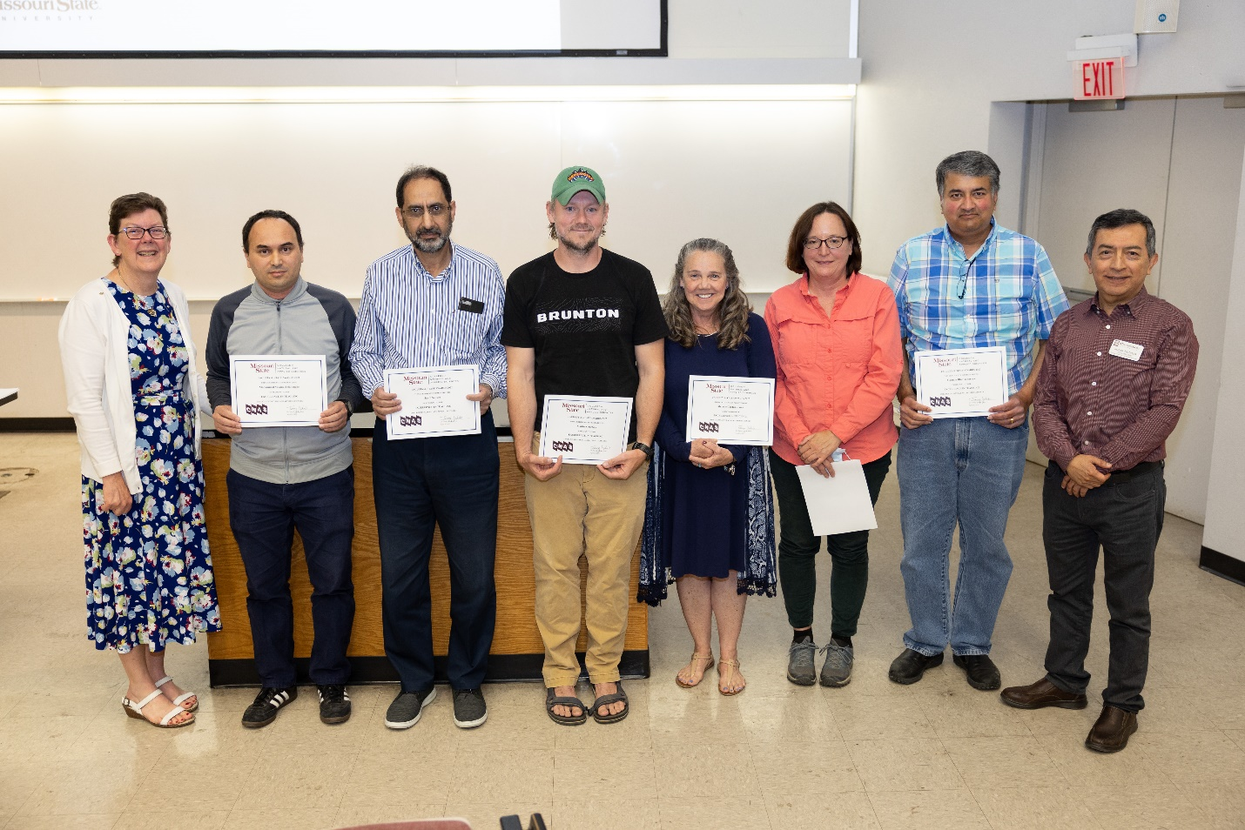

CNAS Faculty Diversity Award

Kyoungtae Kim – Biology

La Toya Kissoon-Charles - Biology

Kyoungtae Kim, professor of biology, has been involved with unique experiences promoting diversity. His committee work includes helping to influence medical school admissions to be more holistic, work with the English proficiency exam committee and serving as a judge for international student presentations. He also works as the Globally Responsive Education and Teaching (GREAT) program advisor and has also worked as a program advisor for the Missouri Louis Stokes Alliances for Minority Participation (MoLSAMP) – a program to increase the number of underrepresented minority (URM) in STEM with Dr. Tayo Obafemi-Ajayi.
La Toya Kissoon-Charles, assistant professor of biology, is an ongoing and long-term member of the Human Diversity Committee in the Society of Wetland Scientists (SWS). As a member of this committee she has reviewed Society position statements, hosted multiple webinars, and executed a workshop at the 2021 annual conference entitled “The Value of Human/Cultural Diversity to Wetland Scientists and SWS”. She is also involved in the SWS Multicultural Program (“SWAMP”), which provides student travel awards and fellowships to SWS students from under-represented groups. Among her colleagues in Kings Street Annex, she is well-known for her Blackboard prowess. Specific to diversity, equity and inclusion, she has fantastic skills at designing fully accessible digital course materials and always gets the green accessibility dial for posted Bb materials.

CNAS Student Nominated Awards for Faculty/Staff Excellence

Nine faculty were nominated by students for this award and the nominees included: Dr. Bradley Mills (PAMS), Dr. Kyoungtae Kim (BIO), Dr. Ngoc Do (MTH), Dr. Steven Senger (MTH), Fan Zhou (MTH), Dr. Gary Meints (CHM), Dr. Dave Cornelison (PAMS), Dr. Gautam Bhattacharyya (CHM), and Dr. Razib Iqbal (CSC). In the words of the students, these faculty truly understand the power of knowledge and they are always willing to help. They provide a learning environment where every student has the potential to succeed. One student also said that the nominee was the most effective teacher that he had ever had! And everyone used the word “passion” in their nomination. Although each person on the list is a winner the students chose four to receive the award for excellence this year.
- Dave Cornelison – The nominating student said, “Dr. Cornelison is the epitome of an ideal professor; someone who will take the time to not only be there for you throughout the ups and downs of class, but also through the ups and downs of life. He truly upholds the tenets of a great professor and a great human.”
- Gary Meints – The nominating student said, “I am not afraid to ask him questions and he is not afraid to be wrong, both of which result in a welcoming, positive environment.”
- Fan Zhou – One nominating student said, “She teaches math so well that I feel any student could learn from her but what is special about her is her warming, caring, understanding and supportive personality. She genuinely cares about each student and goes out of her way to assist each of us as it is evident her passion is for each student to succeed.”
- Gautam Bhattacharyya – The nominating student said, “He is by far the most amazing professor I have ever had. … He never skips a question or makes you feel small for asking. His teaching style corresponds with what we as a class are struggling with the most, and when it is work time with groups, he talks to each one individually.”

Atwood Research and Teaching Award

The Atwood Research and Teaching Award was endowed by Dr. Jerry Atwood a 1964 graduate of MSU and now an internationally known chemist. He started his career at University of Alabama in 1967 but was the department head at University of Missouri-Columbia from 1994 to 2016. In addition, he was appointed a Curators Professor starting in 1999. The award winner receives a certificate and $3000 to be spent over the next year on students, research supplies, summer salary or travel.

The 2022 recipient of the Atwood Research and Teaching Award is Dr. Steven Senger from the department of mathematics.
Dr. Steven Senger is a very active associate professor in the department of mathematics who excels in each of the areas of teaching, research, and service. Steven is a departmental leader in undergraduate mathematics research - currently working with five undergraduates and one graduate student on research in geometric combinatorics. He is also very active in his professional community as an editor of a journal, conference presenter, inviting guest speakers to MSU, and since 2020 he has published seven peer-reviewed research papers, including an interdisciplinary project with professors of physics and engineering here at MSU. He teaches courses of all levels, from general education courses such as pre-calculus, all the way to a new 700-level joint mathematics-computer science course he created on algorithm analysis as he has degrees in electrical and computer engineering in addition to his PhD in mathematics. Steven's dedication to teaching is legendary in the department of mathematics and beyond. His student ratings are consistently well above college averages, his written evaluations are heartwarming to say the least, and he impacts students’ lives by helping them find jobs, presenting at conferences, and gaining admission to PhD programs. Steven is known as a caring professor who makes class fun. We are pleased to recognize Dr. Senger’s excellence in all areas with this award.

