2019 Public Affairs Conference
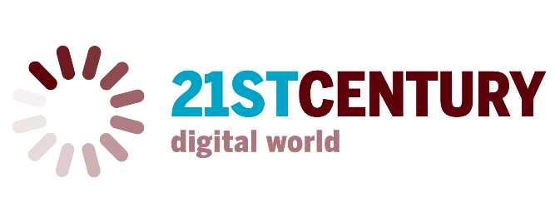

The 21st Century Digital World

Digital technology has transformed the way we live, work and play. Technological innovations improve modern living for many and provide access to opportunities unprecedented in human history. But progress and innovation often come with a price.

While technological advances provide vast new resources, they also present obstacles that require careful attention. Social media platforms offer unparalleled connections between friends, old and new, yet a mirage of intimacy exists that can pave the way for misunderstanding, sexting or cyber bullying. The anonymity of the Internet fosters a level of discourse that often lacks civility and allows people to abrogate responsibility for their words. We now have access to vast resources of knowledge with the click of a mouse, but is this knowledge reliable? Verifiable? Medical specialists can test for disease and share information to better determine a diagnosis, but these advances are expensive and contribute pressure to a health care system that is already under stress. Homeland Security tracks travel behavior to keep us safe, yet those whose names are similar to suspected criminals may suffer unwarranted scrutiny when flagged as suspicious. Robots cut the time and cost, but they also eliminate jobs. How can consumers balance the convenience of online shopping with the risk of loss of privacy and identity theft? What are the implications of virtual reality? Of artificial intelligence?

Faced with the breakneck speed of technological change, how can an individual, a community or a nation celebrate its benefits while gracefully mitigating the price of progress? The 2019 Public Affairs theme, The 21st century digital world, will serve as a vehicle for investigating the impacts and opportunities of the digital world in which we live.

