2019 Public Affairs Conference

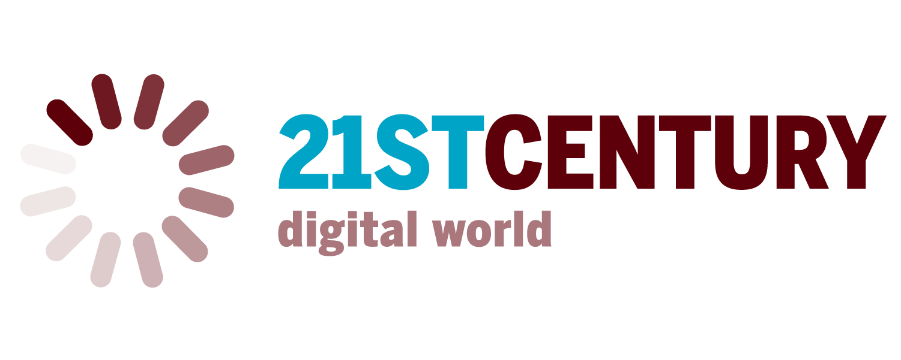
SPEAKER SUBMISSION GUIDELINES

It is now time to begin the exciting process of identifying possible speakers, both panelists and plenary speakers, for the 2019 Public Affairs Conference.

Please contact members of your department, college or organization and begin the process of soliciting names of potential invitees who can address this year’s conference theme of The 21st century digital world. Every committee member should plan to submit one or two names; those representing MSU’s seven colleges are ask to submit two names. Please do not forward all names suggested to you, but use your own judgment and knowledge of the conference to screen submissions, then forward only two names for consideration.

When submitting your suggestions for panelists, please send the email to both conference chair Paul Durham (PaulDurham@MissouriState.edu) and Candace Fisk (CandaceFisk@MissouriState.edu). All suggestions are due by 5:00 pm on Thursday, February 14 and should include the following brief information:

- Name, title, affiliation of proposed panelist
- Basic demographic information (gender, race/ethnicity, disability, LGBTQ status, MSU alumnus, etc.)
- Bio sketch (a paragraph is fine, or feel free to cut and paste a bio up to one page in length); please do not just send us a URL link
- How s/he fits The 21st century digital world theme
- How/why the person was identified (e.g. personal connection? professional contact? recognized body of work? publication?)

You are free, but not obligated, to contact individuals to ascertain their interest and availability, but please do not proffer formal invitations yet. A Talking Points Memo is provided for your use if making initial contacts to ascertain a potential panelist’s interest and availability.

After you have submitted names, Candace Fisk will contact you by Tuesday, February 19 regarding the decision to invite your proposed panelists. Please be prepared to proffer the invitation by Friday, March 1, and ask for a firm response no later than Friday, March 22, 2019.

