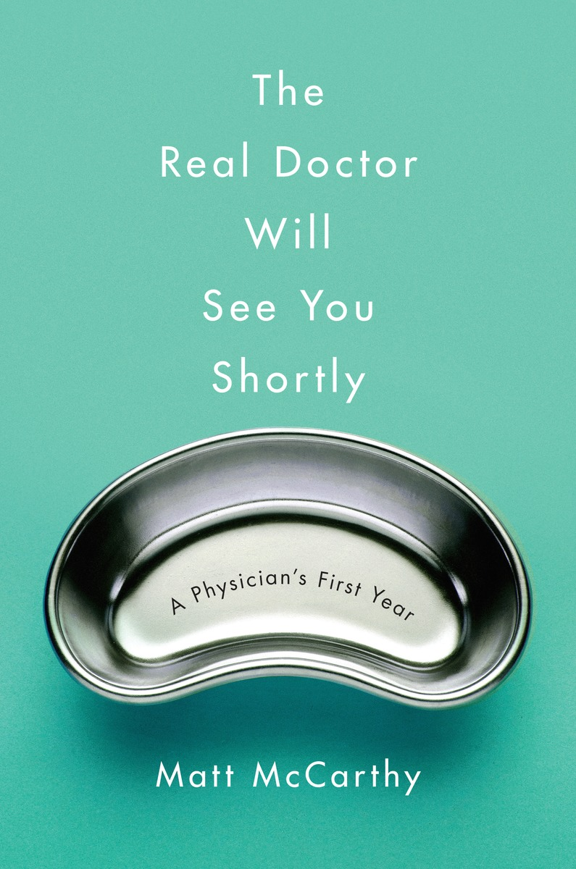

Matt will be speaking about his experience writing and publishing his memoir, *The Real Doctor Will You Shortly: A Physician’s First Year****.***

**MATT MCCARTHY** is an assistant professor of medicine at Cornell and a staff physician at Weill Cornell Medical Center. His work has appeared in *Sports Illustrated*, *Slate*, *The New England Journal of Medicine*, and *Deadspin*, where he writes the Medspin column. His new book, *The Real Doctor Will See You Shortly: A Physician’s First Year*, is now available from Crown Books.

5:30 p.m.

PSU 400

MSU Society for Technical Communication is proud to present

Matt McCarthy

Sponsored by MSU STC

### April 21, 2015

## Aenean a magna vel pede vestibulum rhoncus. Nulla cursus orci quis tortor.